**Blue Paper 2: Impacts of climate change on the ocean ecosystem economy and potential solutions**

**Preferred Journal:** Nature

**Authors**: Steven D. Gaines and coauthors

**Introduction:**

The ocean is critically important to the global economy. Collectively, ocean-based industries contribute approximately US$31 trillion (2.5% of the global economy) and 31 million jobs annually (OECD 2016). These industries can be divided into two categories: (1) those that depend on ocean ecosystems, such as fisheries, aquaculture, and tourism and (2) those that are agnostic to ocean ecosystems, such as energy, maritime equipment, shipping, and transportation. The ecosystem-dependent industries provide approximately a third of annual production value (OECD 2016) and are particularly sensitive to the impacts of climate change.

In this paper, we review the impact of climate change on the 3 key components of the ocean ecosystem economy -- fisheries, aquaculture, & tourism -- and the opportunities for effective institutions and markets to reduce these impacts. Building on existing work, we developed three new models to forecast economic impacts of climate change and potential benefits of adaptation in each sector for every coastal country under diverse climate scenarios.

In the first three sections, we review the observed impacts of historical climate change, the expected impacts of forecast climate change, and the opportunities for solutions in each sector of the ocean ecosystem economy. In the final section, we explore the synergistic impacts of climate change across all three sectors and identify countries vulnerable to universally negative impacts versus countries with opportunities to offset negative impacts in some sectors through adaptation or potentially positive impacts in other sectors. Finally, we conclude with ten recommendations for effectively and equitably maintaining the ocean ecosystem economy under climate change.

**Main text:**

*Capture fisheries*

In 2016, fisheries produced 79.3 million metric tons of landings, employed 30.6 million people, and provided nearly half the planet with a vital source of protein. However, these benefits are challenged by the combined effects of ocean warming, acidification, deoxygenation, and shifting productivity. We review the impacts that climate change has already had on life history, geography, and productivity (Free et al. 2019) as well as projected future impacts (Gaines et al. 2018, Lotze et al. 2019). We present a new analysis that evaluates the benefits each country stands to gain by implementing climate-adaptive fisheries management reforms that address both changes in species productivity and distribution. We show that all countries would benefit from implementing climate-adaptive reforms and that many countries could maintain current profits and catch into the future with adaptation (**Fig. 1**). Finally, we provide recommendations for (1) strengthening international governance; (2) accounting for shifting productivity in management; and (3) building resilience through social and biological reforms.

*Aquaculture*

Aquaculture, the cultivation of aquatic animals and plants, is one of the fastest growing global industries and now produces more seafood than wild capture fisheries. In 2016, ocean aquaculture produced 38.6 million metric tons of seafood worth US$67.4 billion (FAO 2018). We detail how climate change, particularly warming and acidification, has already impacted (De Silva et al. 2010) and will continue to impact the potential for finfish and bivalve aquaculture (Froehlich et al. 2019). We present a new analysis that forecasts the potential for aquaculture under climate change while also accounting for future constraints. We show that aquaculture production is under capacity in many countries (**Fig. 2**) and the negative effects of climate change could be more than offset by sustainable management. Finally, we provide recommendations for increasing aquaculture production by (1) defining best practices; (2) reducing the fish requirements of feed; and (3) selectively breeding mariculture species for fast growth and heat tolerance.

*Marine and coastal tourism*

Marine and coastal tourism is projected to be the top ocean industry by 2030, when it will account for 26% of the ocean-based economy (OECD 2016). Since coral reef tourism is one of the best-studied sectors (Scott et al. 2012), and worth US$35.8 billion globally annually (Spalding et al. 2017), we focus our analysis on this sector. We present a new analysis that combines the model of Chen et al. (2015) and current coral reef tourism values per country and territory reported by Spalding et al. (2017) to project how ocean warming and ocean acidification will change coral cover at the country-level, and how these changes in reef condition would translate to changes in tourism values. We find that coral cover and tourism values for all countries will be negatively impacted, with magnitudes dependent on the climate pathways (**Fig. 3**). For example, the high emission scenario of RCP 8.5 results in a 7-28% reduction in coral cover and 23-66% decrease of on-reef tourism values from 2019 to 2050.

Finally, reducing the impacts of climate change to coral reef tourism involves: (1) increasing coral reef resiliency to climate change through a variety of local management actions; (2) controlling nutrient input from coastal and terrestrial activities through proper waste disposal and waste treatment facilities; and (3) reducing the environmental footprint of tourism as tourism is also a major contributor of greenhouse gas emissions

**Conclusion:**

We present a first-of-its-kind analysis of how climate change will affect fisheries, aquaculture, and coral reef tourism. In this section, we explore options for nations and local communities to best prepare for the impacts of climate change. To motivate local and global actions, we will demonstrate the projected costs of inaction and the benefits of action at the country level. This will reveal the magnitude of climate change impacts to the three major components of the ocean ecosystem economy. We will also explore the ecological and socioeconomic connections of these three ecosystem economies and explore opportunities for positive synergistic actions. Our results will ultimately help guide new ocean investments and positive conservation actions by governments, NGOs, development agencies, philanthropies, and international communities.

**Figures**

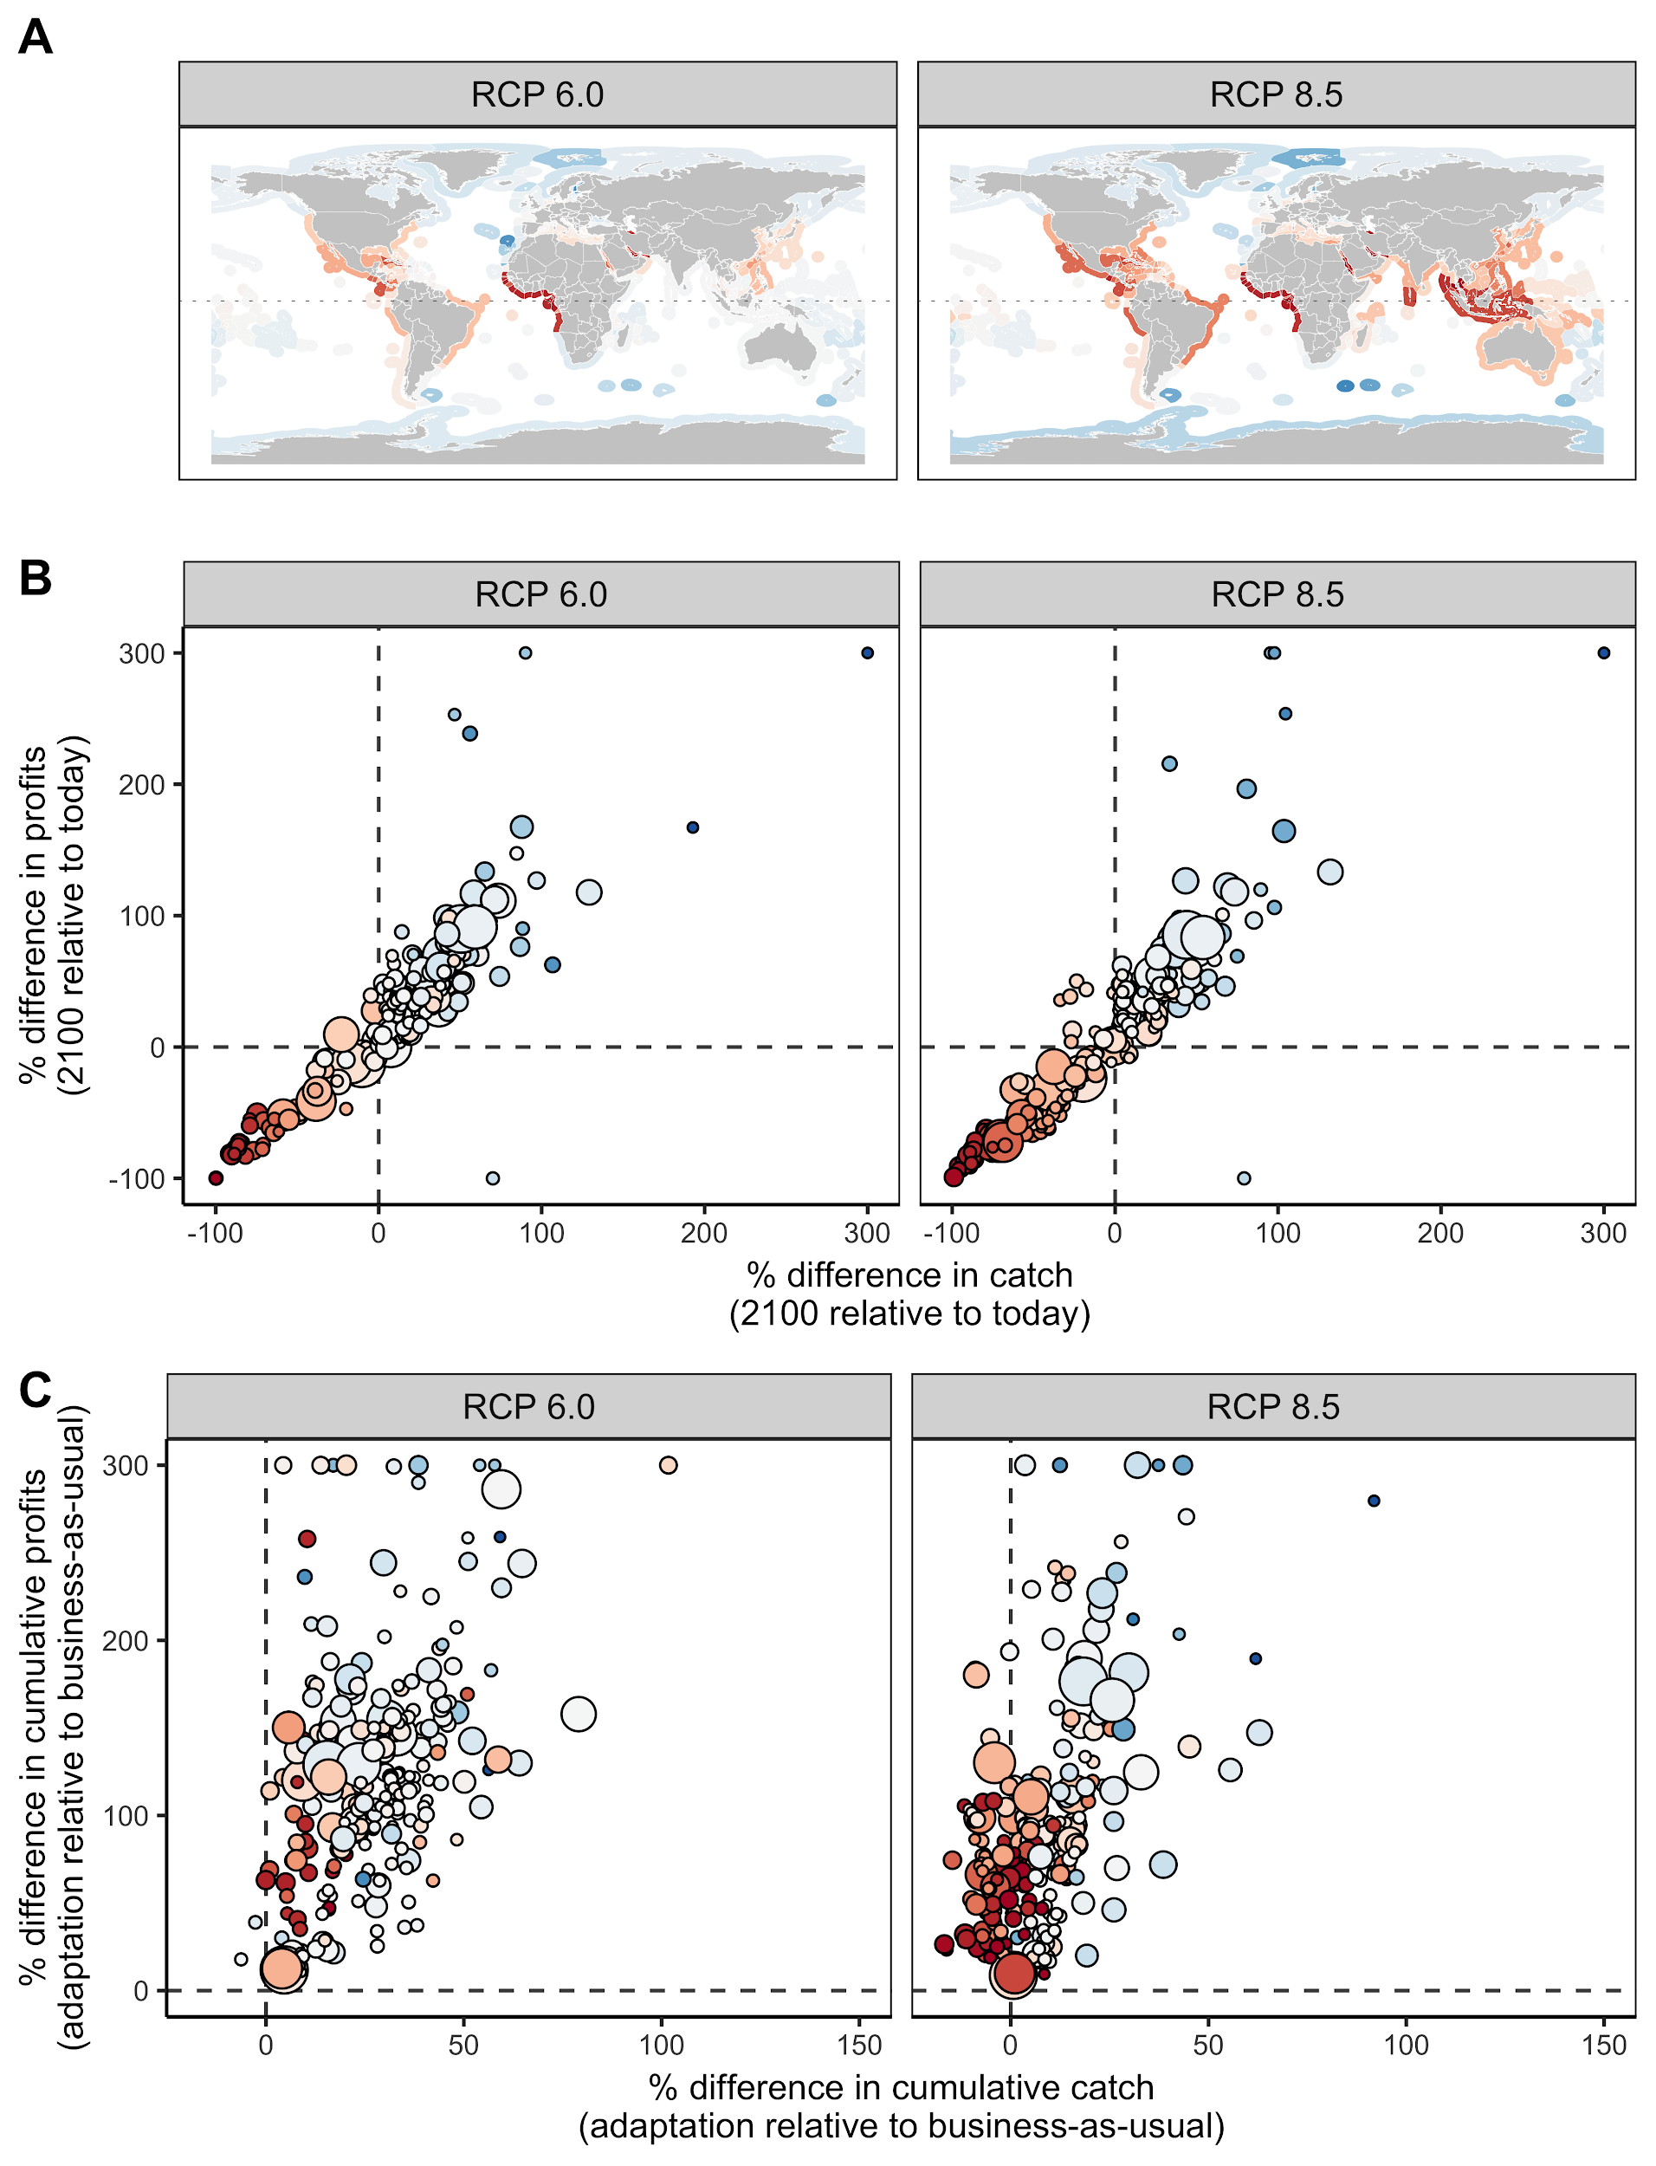

**Figure 1.** Panel **(A)** shows that maximum sustainable yield (MSY) is forecast to decrease in equatorial exclusive economic zones (EEZs) and increase in poleward EEZs through 2100. Panel **(B)** shows that adaptive management results in higher catch and profits in 2100 relative to today for many, but not all, EEZs despite climate change. Panel (**C)** shows that adaptive management nearly always yields more cumulative profits than business-as-usual management and frequently yields more cumulative catches than business-as-usual management.

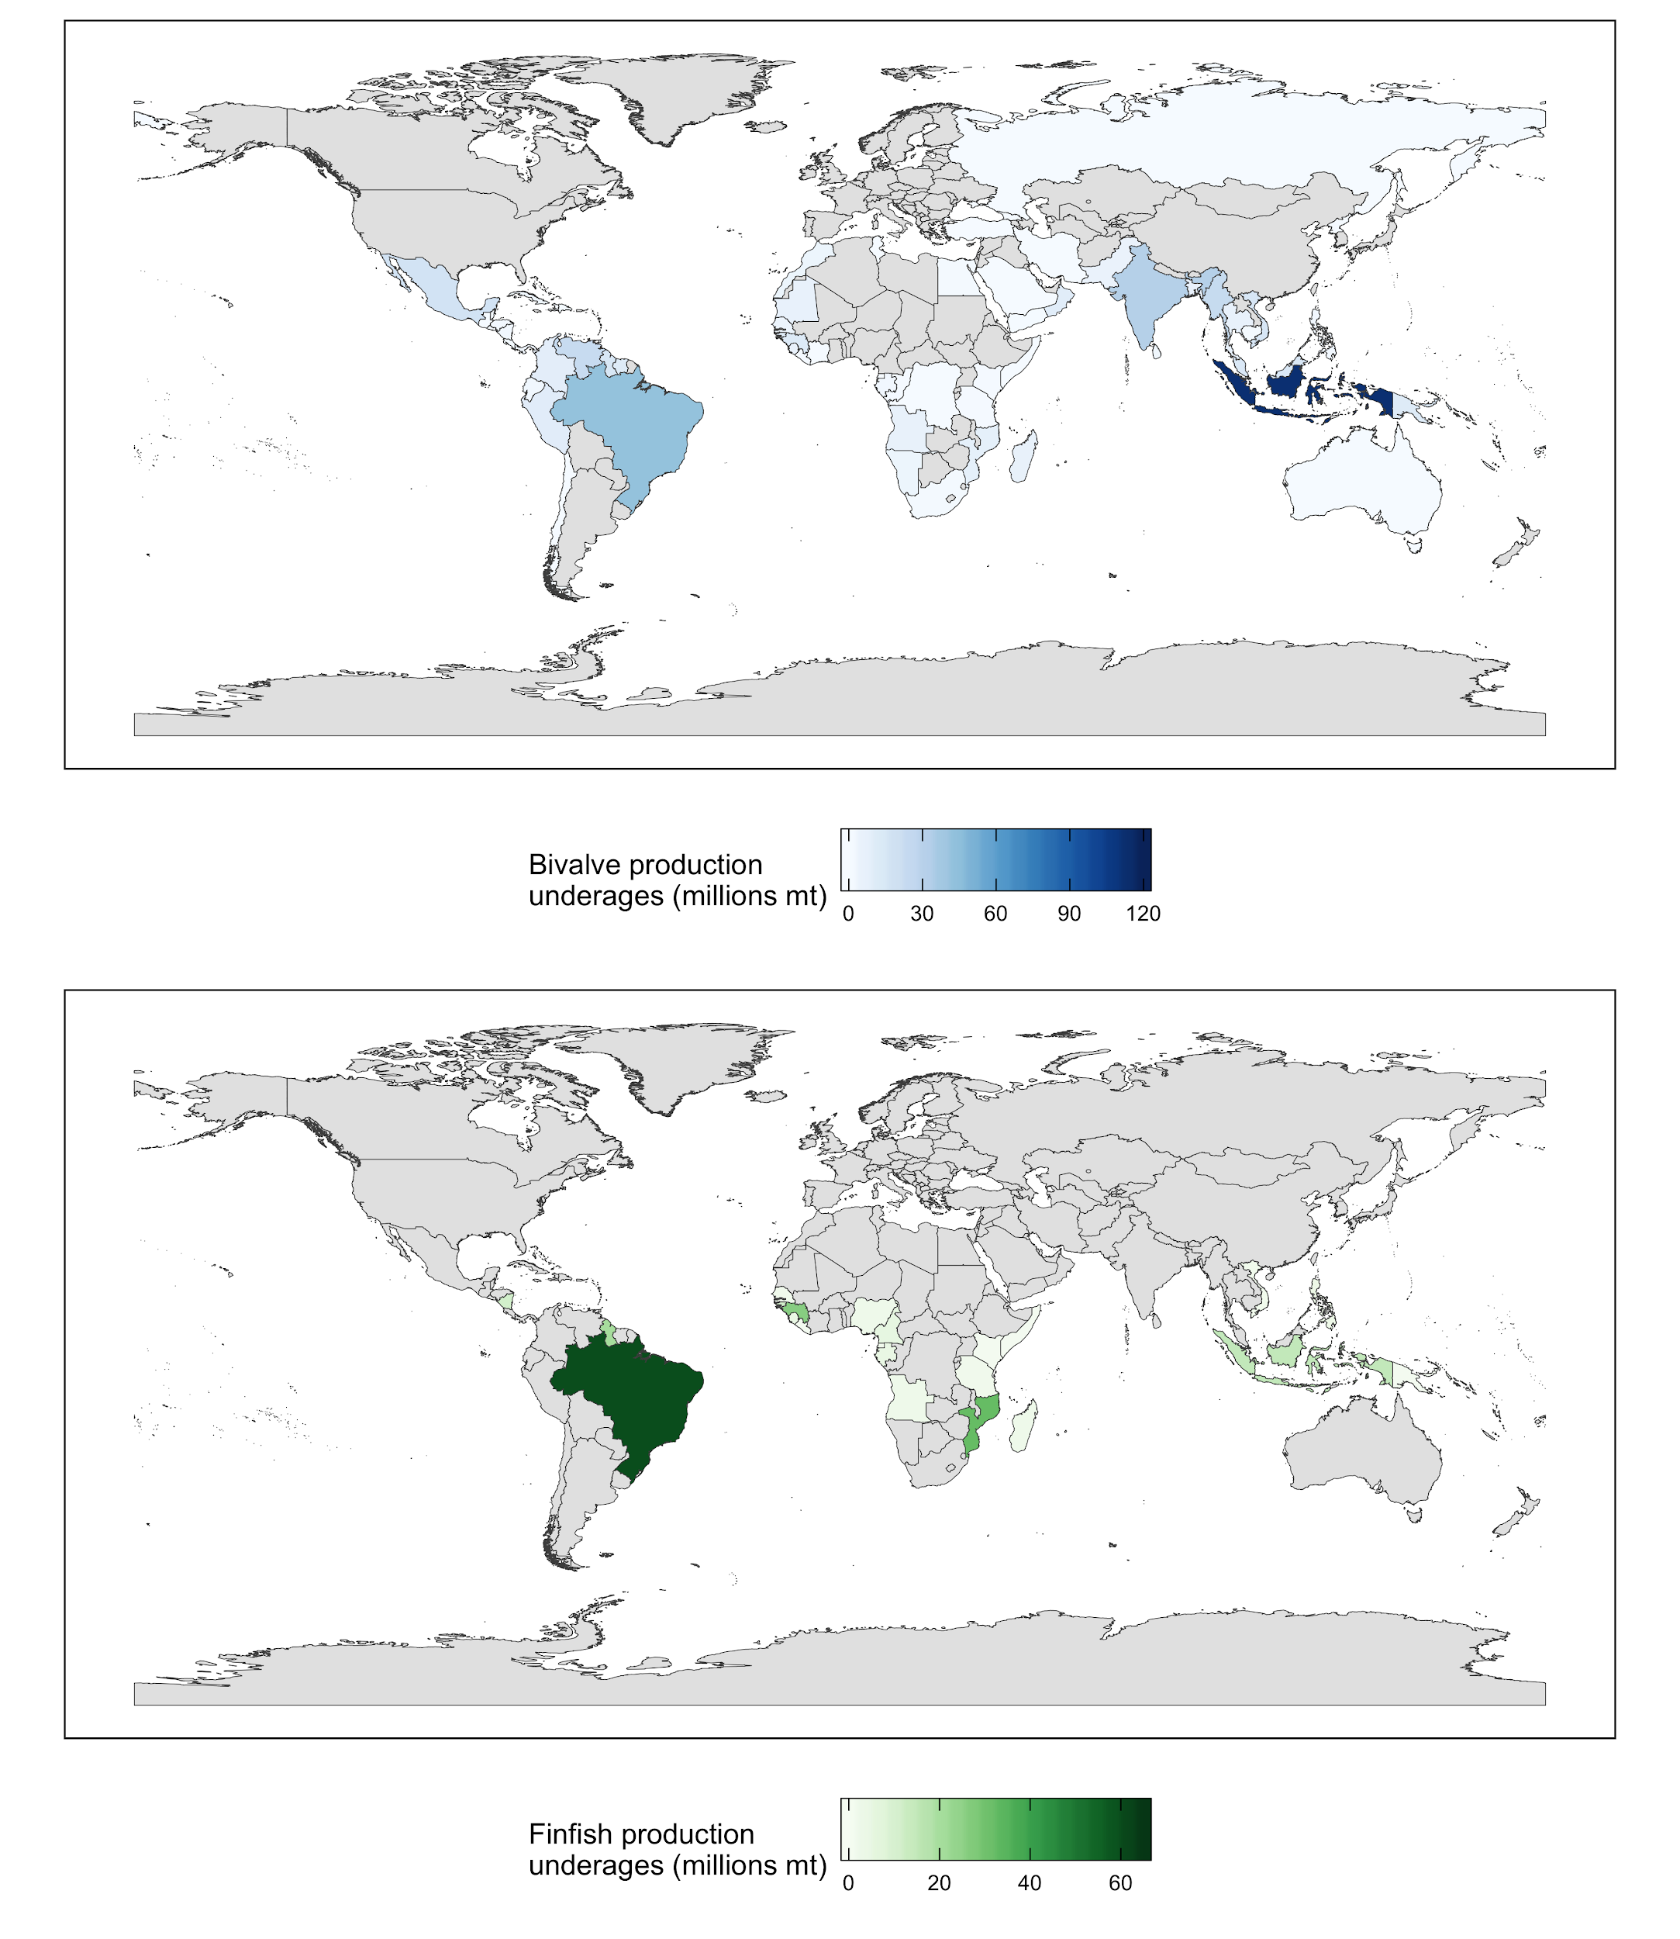

**Figure 2.** Mariculture production underages for (A) bivalves at current prices (US$1,700/mt for blue mussels and (B) finfish at current prices (US$7,000/mt for Atlantic salmon) and a 95% reduction in the reliance of feed on fish ingredients. *[Note: This is a placeholder figure. We will expand this analysis to include climate change projections and other methodological changes.]*

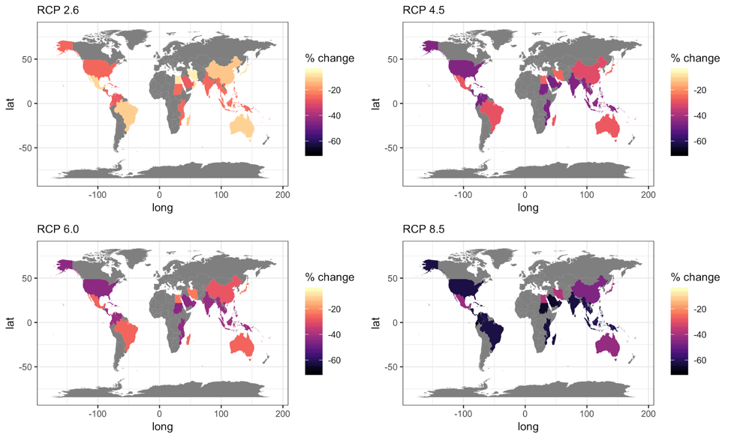

**Figure 3.** Percent change in coral reef tourism values in 2050 (relative to 2019 values) for different climate projections.

**References**

Chen, P.Y., Chen, C.C., Chu, L. and McCarl, B. (2015) Evaluating the economic damage of climate change on global coral reefs. Global Environmental Change 30, 12–20.

FAO (2018) The State of World Fisheries and Aquaculture 2018 - Meeting the sustainable development goals. 1–227.

Froehlich, H.E., Gentry, R.R., Halpern, B.S. (2018) Global change in marine aquaculture production potential under climate change. Nature Ecology & Evolution 2, 1745–1750.

Gaines, S.D., Costello, C., Owashi, B., Mangin, T., Bone, J., Molinos, J.G., Burden, M., Dennis, H., Halpern, B.S., Kappel, C.V., Kleisner, K.M. (2018) Improved fisheries management could offset many negative effects of climate change. Science Advances, 4, p.eaao1378.

De Silva, S.S. (2012) Climate change impacts: challenges for aquaculture. In: Farming the Waters for People and Food. (eds R.P. Subasinghe, J.R. Arthur, D.M. Bartley, et al.).

Free, C.M., Thorson, J.T., Pinsky, M.L., Oken, K.L., Wiedenmann, J., Jensen, O.P. (2019) Impacts of historical warming on marine fisheries production. Science 363, 979–983.

Lotze, H.K., Tittensor, D.P., Bryndum-Buchholz, A., Eddy, T.D., Cheung, W.W., Galbraith, E.D., Barange, M., Barrier, N., Bianchi, D., Blanchard, J.L., Bopp, L. (2019) Global ensemble projections reveal trophic amplification of ocean biomass declines with climate change. Proceedings of the National Academy of Sciences, 116, 12907–12912.

OECD (2016) The Ocean Economy in 2030, OECD Publishing, Paris.

Scott, D., Gössling, S., Hall, C. M. (2012). International tourism and climate change. Wiley Interdisciplinary Reviews: Climate Change 3, 213–232.

Spalding, M., Burke, L., Wood, S.A., Ashpole, J., Hutchison, J., zu Ermgassen, P. (2017) Mapping the global value and distribution of coral reef tourism. Marine Policy 82, 104–113.